Unit 1: Kickstarter Campaign Analysis

Chris McAleer

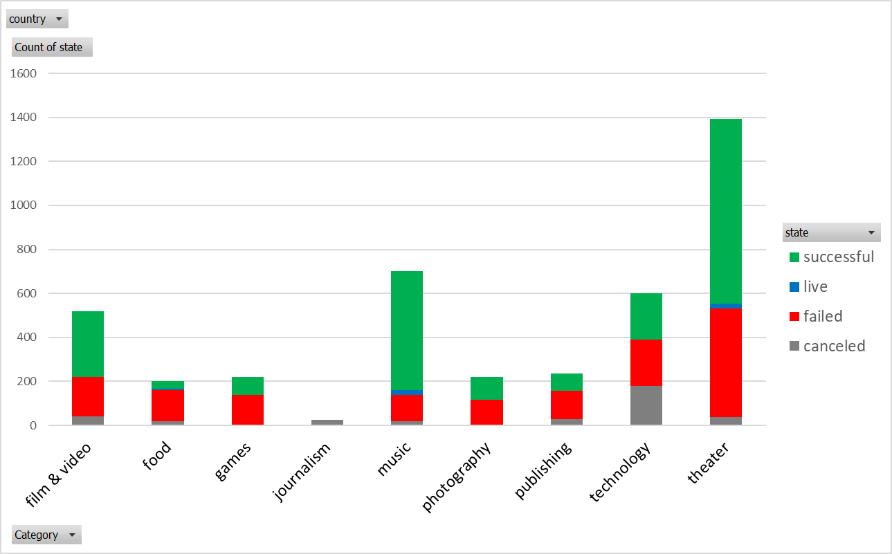

General Observations:

Theater, music, and film & video have more successful campaigns than other categories

All categories except journalism and theater have similar numbers of failed kickstarter campaigns

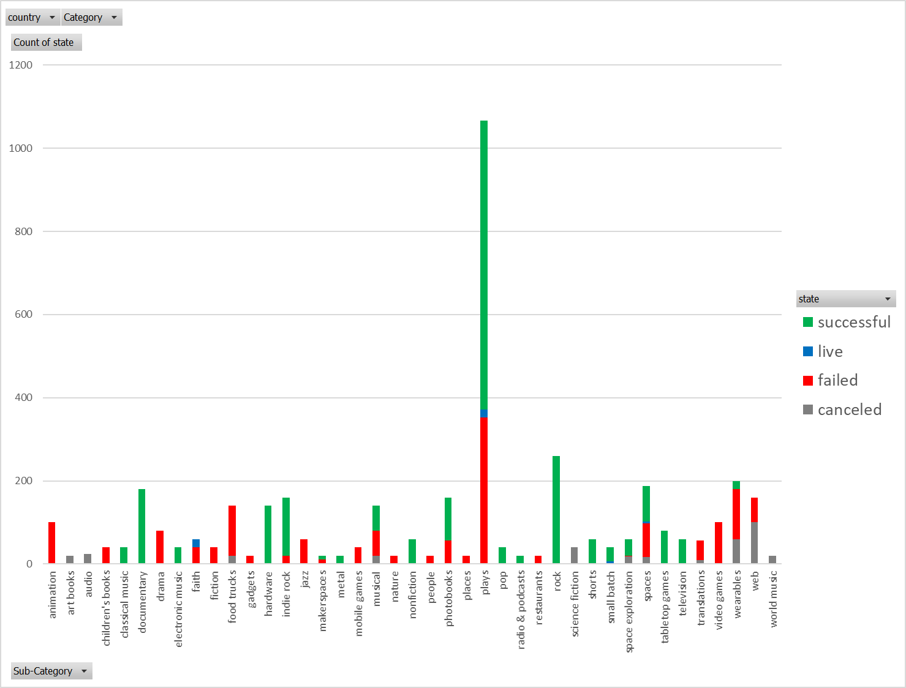

General Observations:

Of all sub-categories, plays had the greatest number of successful kickstarter campaigns

If you want to have a successful kickstarter campaign you should stay away from animation, drama, food trucks, jazz, mobile games, video games, transitions, and wearables as these are predominately populated by campaigns that either all failed or failed/canceled. Yoy should probably look into a kickstarter campaign in classical music, documentaries, hardware, rock, tabletop games, and television, radio, pop, as these campaigns have almost exclusively successful kickstarter campaigns.

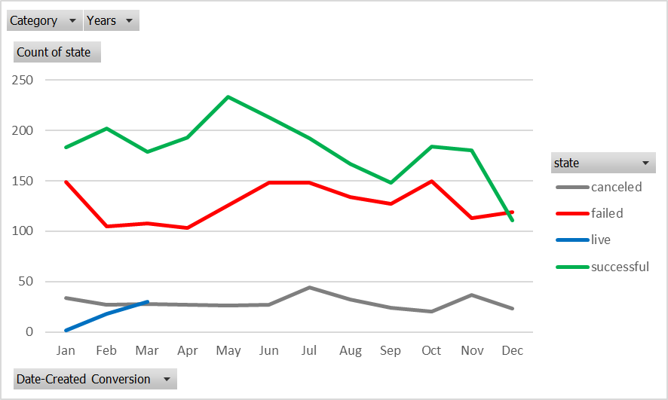

General Observations:

If any observations can be drawn it might be that due to the differences between the number of successful campaigns vs failed campaigns launched in Feb, Apr, may that those would be the ideal times to launch a kickstarter campaign.

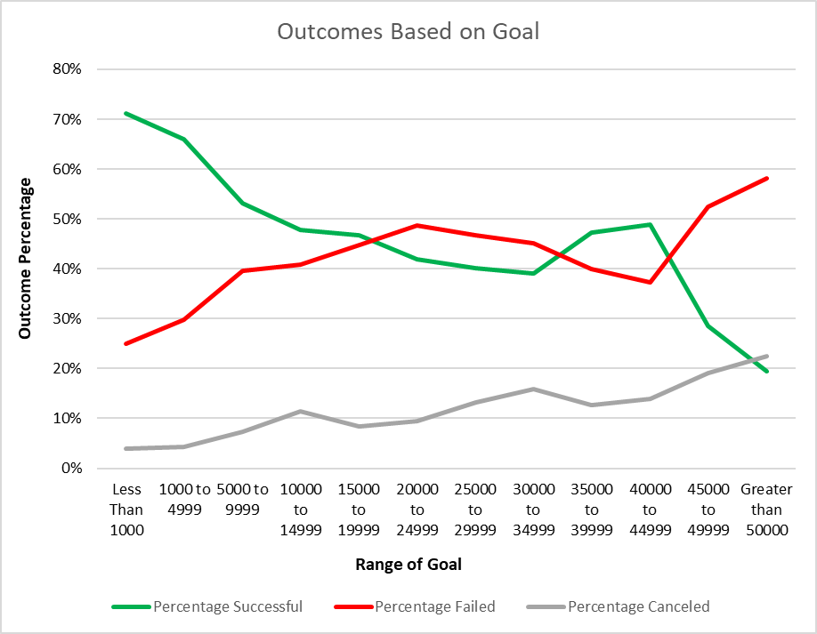

General Observation: If you want the largest chance at a successful campaign than set goals less than $5000.

1. What are three conclusions we can make about Kickstarter campaigns given the provided data?

If you want to have a successful kickstarter campaign you should stay away from animation, drama, food trucks, jazz, mobile games, video games, transitions, and wearables as these are predominately populated by campaigns that either all failed or failed/canceled.

You should probably look into a kickstarter campaign in classical music, documentaries, hardware, rock, tabletop games, and television, radio, pop, as these campaigns have almost exclusively successful kickstarter campaigns.

Due to the differences between the number of successful campaigns vs failed campaigns launched in Feb, Apr, and May that those would be the best times to launch a kickstarter campaign and if you want to further increase your chances of success, set a campaign goal of less than $5000.

1. What are some of the limitations of this dataset?

Limitations to the data itself is it doesn’t take into account any metrics about the feasibility of the proposal set forth that would attract “investors” into donating to the kickstarter campaign thereby increasing or decreasing the probability of success.

Limitations to the set of analytics that were proposed to run are that total counts probably isn’t the best way to analyze this data. For instance, plays has the greatest number of successful campaigns but it also has the greatest number of failed campaigns. As such, there is really only a 65% success rate and a 33% failure rate. However, if we look at Rock or Pop, these campaigns have a 100% success rate but limited number of total launched campaigns compared to “plays”.

The analysis of this data, as requested, will give you general trends in whether you should launch a campaign by subcategory or what dollar amount will give you the best chance of success. However, if you want to get into specifics of a subcategory, time frame to launch, and $ amount goal to set more analysis needs to be done. However, since there was no clear set goal for this analysis perhaps this is enough for the end user.

1. What are some other possible tables/graphs that we could create?

We can create tables or columns calculating the % successfulness and % failure of campaigns by subcategory and maybe further broken down by the dollar amount of the campaign. This will give you a clearer understanding of the exactly what sort of kickstarter campaign to launch.

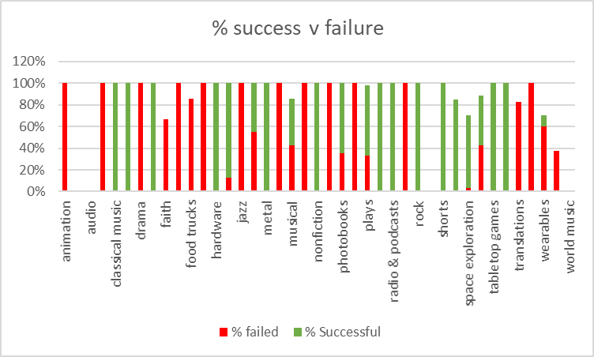

Perhaps we also want to look at the country that has the greatest success

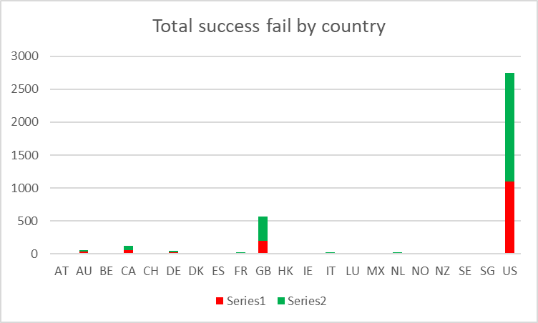

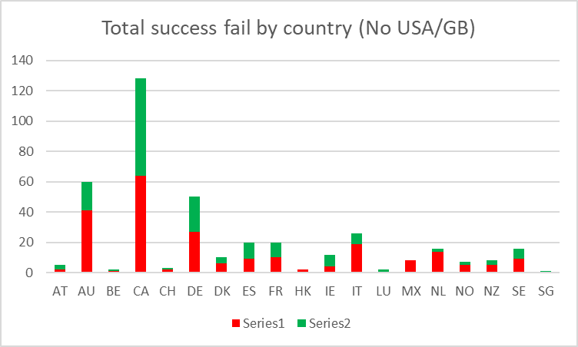

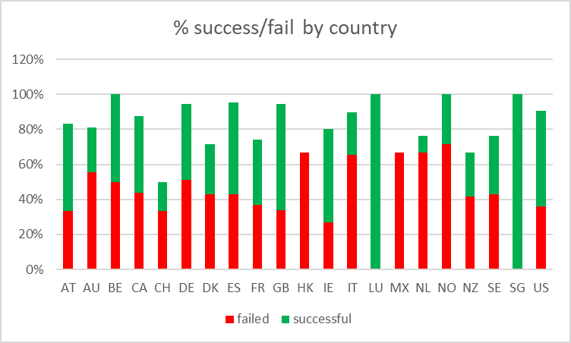

If you want the greatest probability of success launch a kickstarter campaign in SG or LU as they have a 100% success rate and avoid HK and MX as they have a 0% success rate.

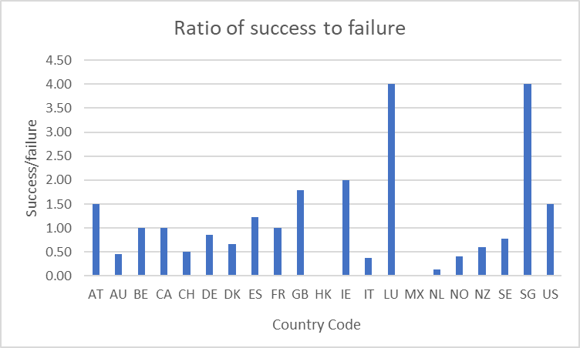

SG and LU have minimal numbers of kickstarter campaigns launched 1 and 2, respectively and perhaps this data is unreliable based on the number of n’s. To help investigate the ratio of successes to failures in an individual country we have plotted success/failures and, excluding LU and SG, the countries that give you the greatest chance of success are IE, GB, US, and AT.